Penny Gallery Exhibition Request

Exhibitions for visual arts and fine craft are scheduled on an ongoing basis, with the jury meeting once per year to set the exhibition schedule. The Charlotte Street Arts Centre is happy to receive applications at any time for review at the next deadline.

Exhibitions are selected by a panel of respected artists and art educators knowledgeable in the discipline involved. In choosing exhibitions, the Charlotte Street Arts Centre will strive to reflect its mandate: integrating the arts and the community by encouraging the development of excellence in the arts. The Penny Gallery is dedicated to showcase work created by Youth (15-25) that are enrolled in school. Individual or group exhibitions!

Information on the Applicant
Name(s) __________________________________________________
Address __________________________________________________
__________________________________________________
Age __________________________________________________
Email __________________________________________________
Telephone __________________________________________________

Requirements Checklist

- CV (PDF or Word)

- Artist statement about the work and what is trying to be achieved (One Page Max in PDF or Word.)

- 10 - 15 samples of work as images on a CD or by email, with an accompanying numbered image list detailing title, media and dimensions. Total submission package must not exceed 8GB in JPEG.

- Upon selection for exhibition, read, agree to and sign Artist Agreement.

Applications should be sent to:

ATTN: Exhibitions Committee

Charlotte Street Arts Centre

732 Charlotte Street, Room 200

Fredericton, NB. E3B 1M5

Or electronically to:

exhibitions@charlottestreetarts.ca

Subject: Penny Gallery Submission

*Please include all attachments as PDFs or JPEGs according to the specifications.

For your information: Artist Agreement for 2018

(To be signed if chosen for an exhibition)

Penny Gallery Artist Agreement

Purchase
The Charlotte street Arts Centre (CSAC) arranges sales to customers and retains a 20% commission on each piece sold. If the Artist has a registered HST number it is the responsibility of the artist to submit claim to CRA. CSAC will charge HST on the 20% commission and all given prices for tag display should include the appropriate cost to be collected by CSAC.

Please check.
Not HST registered.
HST registered. If applicable, indicate HST number: ____________________

Delivery, Setup and Pickup

All pieces of art work will be labelled and priced on the back of each work. Please send artwork titles, dimensions, medium and prices to exhibitions@charlottestreetart.ca at least 4 weeks prior to the exhibit opening for tag display.

If you are HST registered, please indicate your price + hst. The exhibition committee is made up of volunteers that are professional artists who do their best to provide the best experience. However, it is strongly encouraged that you can be available for the install of your exhibit.

Artists are responsible for delivering their work to the Centre, ready for hanging, with wires and screw-eyes. Drop offs need to be during the regular office hours, Monday- Friday, or at another mutually agreed upon time. Artists are responsible for removing/collecting artwork within 24 hours at the end of the exhibition period, unless other arrangements are specifically made. Any delivery of sold pieces is the responsibility of the artist.

General Display Policies
All works must be fully displayed before the exhibit opening and must remain on display during the entire time of the exhibition period. The pieces must be original or credited to the appropriate contributors.

Liability

The Charlotte Street Arts Centre carries basic insurance, which will provide up to $10,000 coverage with a $2500 deductible. Value of works is subject to assessment. Any insurance beyond this amount is the responsibility of the artist(s). Packing, transportation of and handling expenses and risk of loss or damage incurred in the delivery of artworks from the artist to the gallery, and in their return to the artist, shall be the responsibility of the artist.

Opening

The Charlotte Street Arts Centre will cover the cost of a modest exhibit opening. Anything beyond that is the responsibility of the artist(s). Please let us now if there are any dietary or cultural restrictions for food. Any additional food purchased by the artist must meet public health and safety requirements for public consumption. Any purchase of liquor must go through the Centre's liquor licensing requirements. No SALE of alcohol is allowed.

Right to Refuse
The Centre reserves the right to refuse or remove from display any work it considers inconsistent with previously accepted or agreed upon work. The Centre also reserves the right to remove any work that is considered inappropriate for the space.

Photographic and Promotional Rights
CSAC reserves the right to photograph and/or have photographed any or all works of art for promotional or record-keeping purposes. CSAC has the right to publish the name, likeness and biography of the artist and to reproduce and distribute material incorporating photographs of the artist’s works in order to promote the exhibition, sales and the art walk.

Publicity
CSAC will send out media releases, place notices in the Fredericton Arts Alliance Arts News, and on our website and social media outlets. CSAC will arrange design and printing of 25 posters for each exhibition. Invitations are the responsibility of the exhibitor, and must display the Charlotte Street Arts Centre branding and logo, meeting approval by the CSAC administration before distribution.

Artists will submit an exhibition title, a high quality image of work and an artist statement at least six weeks in advance to exhibitions@charlottestreetarts.ca so that appropriate publicity can be arranged.

Fredericton Arts and Learning Inc.

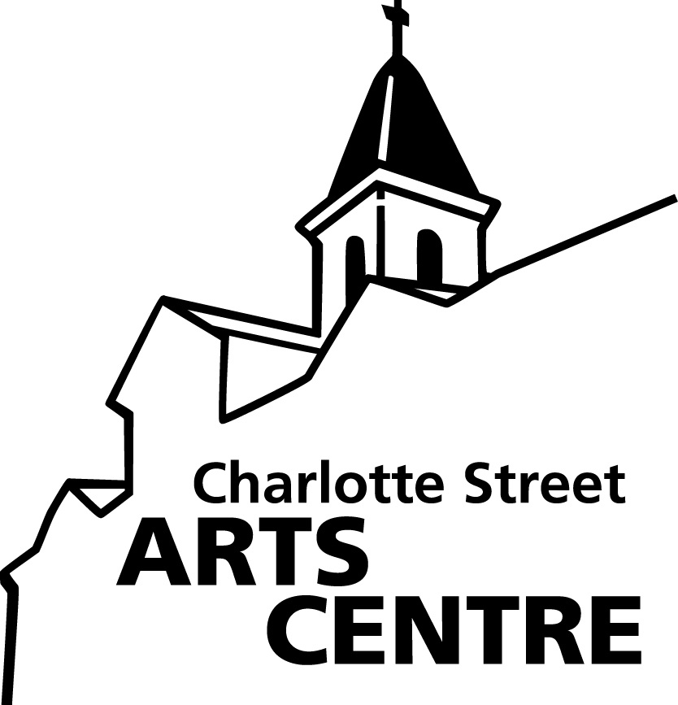
732 Charlotte Street, Fredericton, NB E3B 1M5 • (ph) 454-6952 • (fax) 454-6956 www.charlottestreetarts.ca

